Design and Implementation of Student Accommodation System

(Preference Matching)

**BY**

**Maryam Abba Yusuf**

**BU/22B/IT/6965**

**IN PARTIAL FULFILMENT OF THE REQUIREMENT FOR THE AWARD OF BACHELOR OF SCIENCE IN SOFTWARE ENGINEERING, FACULTY OF COMPUTING AND APPLIED SCIENCE, BAZE UNIVERSITY, ABUJA.**

**September,2024**

# DECLARATION

I hereby declare that this research project has been written by me under the supervision of Dr. Usman Bello Abubakar. The work has been presented in any previous research for the award of B.Sc degree to the best of my knowledge. The work is entirely mine and I accept the sole responsibility for any errors that might be found in the work, while the reference to publish material have been duly acknowledge.

__________________________ _____________________

Maryam Abba Yusuf Date

BU/22B/IT/6965

**APPROVED BY**

_____________________

**Head of Department,**

Department of Computer Science

# CERTIFICATION

This project entitled “Design and Implementation of Student Accommodation System (preference matching)” meets the requirements governing the award of Bachelor of Science in Software Engineering in Baze University, Abuja.

# APPROVAL

# This is to certify that the research work title Design and Implementation of Student Accommodation System (Preference Matching) by Maryam Abba Yusuf with BU/22B/IT/6965 has been approved by the Department of Computer Science, Faculty of Computing and Applied Science, Baze University, Abuja, Nigeria.

By

Dr Usman Bello Abubakar

Supervisor Date

Dr Usman Idris Abubakar

Head of Department Date

Prof Helen Negbenebor

Dean, Faculty of Computing and Applied Science Date

Prof Choji Davou Nyap

External Examiner Date

# DEDICATION

I dedicate this work to Allah (SWA), my source of inspiration, knowledge and understanding, who gave me the grace and strength throughout this program. I also dedicate this work to my parents, for their love and support throughout my life.

# ACKNOWLEDGMENT

All praise, first and foremost, is to God Almighty for His guidance and abundant blessings. My deepest appreciation goes to my parents and siblings for their unwavering love and support. I would also like to acknowledge my project supervisor, Mr. Usman Abubakar, for his invaluable assistance, enduring the stress of reviewing my work and providing necessary feedback. I am deeply grateful to Mr. Alee Dauda for his constant support and guidance throughout this project. His insights and encouragement played a key role in its successful completion.

# ABSTRACT

Many students encounter difficulties finding suitable accommodation after being admitted to university. To address this issue, a Student Accommodation System has been developed to assist students in finding hostels that meet their specific requirements through preference matching. This system offers a comprehensive list of hostels, which are regularly updated by administrators. Through the platform, students receive personalized recommendations for hostels that align with their preferences. By leveraging preference matching, the system ensures that recommendations are tailored to each student's unique needs, providing a pre-visit insight that helps them secure appropriate accommodation with greater ease. The Student Accommodation System benefits both students and hostel owners. For students, it simplifies the search process, reduces the stress associated with finding accommodation, and ensures that recommendations reflect their individual preferences. For hostel owners, it enhances visibility and extends their reach within the city, potentially resulting in increased bookings. The system serves as a bridge between students and hostel providers, making the accommodation search more efficient and effective for all parties involved.

Table of Contents

DECLARATION ii

CERTIFICATION iii

APPROVAL iv

This is to certify that the research work title Design and Implementation of Student Accommodation System (Preference Matching) by Maryam Abba Yusuf with BU/22B/IT/6965 has been approved by the Department of Computer Science, Faculty of Computing and Applied Science, Baze University, Abuja, Nigeria. iv

DEDICATION v

ACKNOWLEDGMENT vi

ABSTRACT vii

LIST OF TABLES x

LIST OF FIGURES xi

CHAPTER ONE: INTRODUCTION 1

**1.1 Overview** 1

**1.2** **Background and Motivation** 1

**1.3 Statement of the Problem** 2

**1.4 Aim and Objectives** 2

**1.5 Significance of the Project** 2

**1.6** **Project Risks Assessment** 3

**1.7 Scope/Project Organization** 3

**1.8 Definition of Terms** 3

CHAPTER 2: LITERATURE REVIEW 4

**2.1 Introduction** 4

**2.2 Historical Overview** 4

**2.3 Preference system** 5

**2.4** **Related Work** 6

**2.5 Summary** 12

CHAPTER 3: REQUIREMENTS, ANALYSIS, AND DESIGN 14

**3.1 Overview** 14

**3.2 Adopted Methodology** 14

**3.2.1 Method 1 (Interview)** 15

**3.3 Tools and Techniques.** 15

**3.4 Ethical Consideration** 15

**3.5 Requirement Analysis** 15

**3.5.1 Software Requirements** 15

**3.5.2 Hardware Requirements** 15

**3.6 Requirements Specifications** 16

**3.7 System Design** 17

3.7.1 Application Architecture 17

3.7.2 Use Case 19

**3.7.2.1 Use-Case Description** 20

**3.7.3 Activity Diagrams** 23

**3.7.4 Entity Relationship Diagram** 26

CHAPTER 4: IMPLEMENTATION AND TESTING 27

**4.1 Overview** 27

**4.2 Main Features** 27

**4.3 Implementation Problems** 28

**4.4 Overcoming Implementation problem** 28

**4.5 Testing** 28

**4.5 Use Guide** 33

**4.7 User Interface Design** 34

CHAPTER 5: DISCUSSION, CONCLUSION AND RECOMMENDATION 42

**5.1 Overview** 42

**5.2 Objective Assessment** 42

**5.3 Limitations and Challenges** 42

**5.4 Future Enhancements** 43

**5.5 Recommendations** 43

**5.6 Summary** 44

REFERENCES 45

APPENDICES 47

# 

# LIST OF TABLES

Table 1.1 Project Risks Assessment 2

Table 2.1 Comparative Analysis of the Related work………………………………………………….... 10

Table 3.1 Functional Requirement Specifications……………………………………………….19

Table 3.2 Non-Functional Requirement Specifications…………………………….……………20

Table 3.3 Use-Case Description for login/Register……………………………………………………….21

Table 3.4 Use-Case Description for Search Accommodation…………………………………………….22

Table 3.5 Use-Case Description for View payment(Admin)………………………………………….….23

Table 4.1 Testing for User sign up…………………………………………………………………….….29

Table 4.2 Testing for User sign in.………………………………………………………………………..30

Table 4.3 Testing for Admin…….………………………………………………………………………..31

Table 4.4 Testing User Preference………………………………………………………………………..32

Table 4.5 Testing for Room Selection….………………………………………………………….….….33

Table 4.6 Testing for Payment………………………………………………………………………...….34

# 

# LIST OF FIGURES

Figure 3.1 Agile methodology………………………………………………………………………….14

Figure 3.2 System Architecture(Student)……………………………………………………………….18

Figure 3.3 System Architecture(Admin)………………......….………………………………………....19

Figure 3.4 Use case Diagram……………………………………………………………………. .….….20

Figure 3.5 Activity Diagram(User).……………………………….………………………………….....24

Figure 3.6 Activity Diagram(Payment)……… ….……………….………………………………….….25

Figure 3.7 Activity Diagram(Registration)……………………….………………………………….….26

Figure 3.8 Entity Relationship Diagram.….…….……………………………………….………………27

Figure 4.1 Login page(Admin)……………………………………………………………………….….35

Figure 4.2 Model page...…………………………………………………………………………………36

Figure 4.3 Dashboard (Admin) page.……………………………………………………………………36

Figure 4.4 Apartment page...………………………………………………………………………….…37

Figure 4.5 Room page...…………………………………………………………………………………37

Figure 4.6 Booking/payment page...……….….………………………………………………………...38

Figure 4.7 Sign page(User)…….………………………………………………………………….….…39

Figure 4.8 Login page(User)……………………………………………………………………….……39

Figure 4.9 Preference page...…………………………………….………………………………………40

Figure 4.10 Apartment page(User)...……………………………………………………………….……40

Figure 4.11 Room page...…………………………………………………………………………...……41

Figure 4.12 Booking page...…………………………………………………………………………...…42

Figure 4.13 Payment page...……………………………………………………………………………...42

# CHAPTER ONE

# INTRODUCTION

## **1.1 Overview**

This project aims to develop a modern student accommodation system for students in Abuja, leveraging a recommender system. The goal is to deliver personalized housing recommendations tailored to individual preferences. By automating the search process, this system will significantly reduce the time and effort students spend finding suitable accommodation, while also optimizing house allocation.

## **1.2 Background and Motivation**

Student accommodation is a critical aspect of university life, ensuring that students have safe, affordable, and convenient places to live while pursuing their studies. In Abuja, the capital city of Nigeria, the demand for student housing has surged with the growing number of higher education institutions and students. Options range from university to private student housing complexes, shared apartments. However, finding the right accommodation that meets the diverse needs and preferences of students remains a challenge in Abuja's dynamic real estate market.

Initially, the process of finding student accommodation was manual, relying on physical visits, word of mouth, and simple listings. This approach was time-consuming, and often resulted in mismatches between students’ needs and available housing options (Johnson, 2019). As student populations grew and the variety of housing options expanded, these manual processes became increasingly inadequate.

The system developed for this project leverages modern algorithms to match students based on their stated preferences. This approach is both personalized and data-driven, ensuring that users are matched with roommates and rooms that align with their living style.

The main goal of this system is to improve the student living experience by minimizing potential conflicts between roommates and promoting positive interactions. Students can specify their detailed preferences, which the system uses to suggest compatible rooms and roommates. This process is efficient, benefiting both students and accommodation managers by saving time and effort.

Additionally, the system gives students a sense of empowerment, knowing their living preferences are considered, which can result in higher satisfaction and increased retention for housing providers.

## **1.3 Statement of the Problem**

Students often struggle to find suitable accommodation due to limited knowledge of available options and difficulty matching their preferences with available housing and roommates. This project addresses these challenges by proposing a **Student Accommodation System Using Preference Matching**, which helps students find accommodation that aligns with their specific needs, simplifying the search process and improving satisfaction.

## **1.4 Aim and Objectives**

The main aim of this research is to design and implement a student accommodation using recommender system to match users with a roommate base on their preferences.

1. To develop a comprehensive and user-friendly software that assists student in finding suitable Accommodation
2. To create a booking and reservation system that allows users to secure their chosen Accommodation, manage bookings, and handle payment transactions securely.

3. To develop a user-friendly platform where students can create profiles specifying their accommodation requirements (location, lifestyle preferences).

## **1.5 Significance of the Project**

The Student Accommodation system using preference matching is significant as it offers many benefits:

1. It ensures that students find suitable accommodation quickly and accurately.
2. Users are provided with a system that enables them to select accommodations according to their preferences
3. It reduces the time and effort required for manual accommodation.
4. Helps in efficient allocation and management of housing resources.

## **1.6 Project Risks Assessment**

**Table 1.1 Project Risks Assessment**

|  |  |
| --- | --- |
| RISK | IMPROVEMENT |
| Inability to carry out research due to loss of hardware/software resources | Be aware of and observe school IT security procedures  How to keep your Android phone secure when not in use |
| Preventing work loss in case of equipment failure or loss | Daily Backup of data to multiple sources of storage such as flash drives, hard drives, google drive, etc. for multiplicity |
| We will explore alternative APIs if the required APIs are not available | We will identify the software requirements early to address any potential software conflicts. |

## **1.7 Scope/Project Organization**

This project was arranged into five chapters: Chapter one as an introduction to the general aim and objective of the project, and the ideas at focus presented. Chapter two deals with relevant literatures of components used in realizing this project while Chapter 3, is design methodology, Chapter 4, is implementation of the methodology and testing. Chapter 5 covered conclusions, limitations, and suggested improvements for the system.

## **1.8 Definition of Terms**

Accommodation: refers to any space, whether a single room, a group of rooms, or an entire building, where a person can reside or stay.

Preference Matching: refers to a process where individuals or entities provide their preferences, and a system or algorithm tries to match those preferences with available options to find the best possible outcome

# CHAPTER 2

# LITERATURE REVIEW

## **2.1 Introduction**

The literature review chapter aims to provide a comprehensive overview of the existing knowledge and research related to the development of a student accommodation system using preference matching. This chapter will look into the historical evolution of accommodation systems, examine previous research and implementations of using preference matching systems in the housing sector, and identify gaps and limitations in current solutions. By critically analyzing the literature, this study seeks to build upon existing knowledge and contribute to the advancement of an efficient and personalized student accommodation system. The exploration of literature will inform the design and implementation of a robust recommendation system tailored to meet the diverse needs of students in Abuja, ensuring optimal matching of preferences with available housing options.

## **2.2 Historical Overview**

Before the advent of digital technology, the process of finding student accommodation was largely manual and time-consuming. Students relied on notice boards, real estate agents, or university housing offices. There was little focus on matching accommodation options to student preferences, and the process lacked personalization. It was mostly driven by availability and affordability, with students often having limited access to detailed information about their potential living spaces. By the late 1990s and early 2000s, the rise of the internet revolutionized the housing search process, including student accommodation. Early platform and various student housing websites, offered digital listings, allowing students to browse available properties more easily. However, these systems typically featured basic filtering options like price, location, and number of rooms.

The 2000s and early 2010s saw the emergence of specialized student housing platforms designed specifically for university students. Websites like Uniplaces, Student.com, and HousingAnywhere catered directly to student accommodation needs, offering more user-friendly interfaces and better filtering options.

During this time, these platforms began to recognize the importance of preference matching. Basic algorithms were developed to rank listings based on simple student preferences, such as proximity to university campuses or rent budgets. However, the ability to match students with accommodations based on more detailed criteria (such as personal preferences) remained limited.

## **2.3 Preference system**

**How the Preference System works**

Collecting User Preferences: After student’s log in, they are required to specify their roommate preferences, which include key factors like cleanliness, sleep habits, quietness, and social behavior. These attributes play a vital role in helping the system identify compatible roommates.

Filtering Available Rooms: When a student begins searching for accommodation, the system first narrows down available rooms by considering the user’s preferences. The get filtered room recommendations function filters out rooms that do not meet the student’s gender preference, only showing rooms with available spots that align with the user's requirements.

Calculating Match Percentages: A significant part of the preference-matching process is carried out by the calculate match percentage function. This function compares the student's preferences with those of the current occupants in a room, calculating a match percentage. The algorithm evaluates how closely the student's preferences for cleanliness, quietness, and socialness align with those of the existing occupants. It does this by calculating the absolute difference between the user's and occupants' preferences. The closer the values are, the better the compatibility and, as a result, the higher the match percentage.

Ranking Rooms: Once match percentages are computed for all available rooms, the system ranks them from the highest to the lowest match percentage. This ensures that the student is presented with rooms that best match their preferences, increasing the likelihood of finding a room that meets their expectations.

Example:

If the user prefers a high level of cleanliness (e.g., a score of 10) and the current occupant prefers a medium level of cleanliness (e.g., a score of 5), the system records a difference of 5. The process is repeated for other preferences, such as quietness and social behavior, and the differences are summed up. If a room has no current occupants, it is treated as a perfect match, with a score of 100%.

## **Related Work**

Su and Khoshgoftaar, (2019) Lakshmi and Lakshmi, (2014); observed that when a new item or a new user is introduced to a recommendation system, the system will not have any past records (ratings, preferences, search history, etc.) on the basis of which recommendation should be made. This is known as the cold start problem. It is also termed as the new user problem or new item problem. A solution to this problem includes exploiting the demographic information of the user obtained from the user’s profile. This solution is insufficient and not completely correct as users with the same demographic features may show varying interests towards a particular item.

Lu et al., (2015) A lot of work has been done by the research community to enhance the applicability and performance of Recommendation systems over the last few years. It is known as the new user problem or new item problem. One approach to addressing this issue involves leveraging the demographic data derived from the user's profile. However, this approach is inadequate and not entirely accurate because users with similar demographic characteristics may exhibit different levels of interest in a specific item. These algorithms mainly follow demographic filtering, content-based filtering, collaborative filtering and hybrid approaches.

Dejo et al., (2015), Zhang et al., (2016) and Bernardes et al., (2015). Nowadays social networking sites (such as Facebook, Twitter, etc.) have emerged as a substantial platform for applying Recommendation systems. These popular sites are considered to be the major source of information about people and hence becoming a great option to leverage novel and innovative approaches for the recommendation, leaving behind the old methods, to increase the accuracy. Social networking sites contain contextual information like time, location, and the emotions of individuals and groups, which can lead to the development of a new recommendation system known as contextual Recommendation system. This also offers the potential to introduce a dynamic element into recommendations. Additionally, seasonal marketing and conference recommendations are becoming significant application areas within context-aware recommendation. This is the most recognized and widely implemented recommendation system (Singh et al., 2019). follows the philosophy of “a man is known by his company he keeps.” That means if believes that if two or more user’s interests matched in the past, It's probable that their interests will continue to align in the future. For example, if the purchase histories of user1 and user2 strongly overlap then it is high on the cards When user1 makes a purchase, user2 will also purchase the same or a similar product. Collaborative Filtering methods involve monitoring a user's previous reviews and ratings of items in order to suggest similar items in the future. Even if the user did not deal with a particular item, it would be recommended to him if his peers have used the same. It is obvious that to achieve reasonable recommendation accuracy a large number of user groups are required to be considered, trust is an important factor for reliable recommendation.

Pelánek, (2018), Wang et al. (2015b) and Peis et al., (2018) stated that many problems of common Recommendation systems are eliminated by using semantic-based RS. More details of the semantic-based Recommendation system can be found in the article, as an example, may be referred to, where the authors proposed and evaluated the preference of a semantic-based friend RS for the social network.

Wang et al. (2015b) and Pelánek, (2018) implies that metadata of a user profile and item description are used to establish a proper matching for the recommendation. Many problems of common Recommendation system are eliminated by using semantic-based recommendation system. More details of the semantic-based Recommendation systems can be found in the article as an example, may be referred to, where the authors proposed and evaluated the preference of a semantic-based friend Recommendation system for the social network

Tewari, A.S. and Priyanka, K. (2015) stated that as the Recommendation systems work on large datasets, the complexity of the system increases in case of a huge number of users and millions of distinct items set. Numerous systems must promptly respond to online requests and provide recommendations to all users based on their purchase and rating history, necessitating high scalability of items.

Meymandpour and Davis, (2015) and Amazon.in, (2017a, 2017) Most of the Recommendation systems) are unable to find the same or similar items with different names (synonyms). Due to this limitation, certain issues arise. For instance, 'children movie' and 'children film' essentially refer to the same things, but memory-based CF systems won't be able to match them to calculate similarity.

Lakshmi and Lakshmi, (2014), Sarwat et al. (2015), Mayeku et al, (2015) and Orellana-Rodriguez et al (2015) stated that if the system is not familiar with the abbreviations that the users often use during online interactions. It won't be capable of identifying the specific item the user is searching for. This generates an erroneous recommendation. The solution is to categories the abbreviated words with their full forms and put both the names on the same list. If the target user’s contextual information is available, we can make the system recognize various attributes like time, location, companion, mood, etc., can define a context. Demographic information differs from contextual information in that a user's demographic characteristics generally remain constant for a longer duration, while contextual information changes based on the situation. To capture the emotional context, a hefty amount of data managed which leads to various challenges, have proposed system that can be built into a database system. A context-aware online learning platform has been introduced in. An efficient method for extracting valuable contexts from user comments on YouTube has been presented.

Wang et al. (2015a) present a Bayesian network classifier (i.e., a probabilistic model) is applied to solve classification problems in huge networks like social networks. To solve the user’s cold start problem and improve accuracy in the recommendation, proposed a trust-based probabilistic recommendation model for social networks.

Zhang and Zhou (2014) Support vector machine (i.e., supervised learning) is used with an associated learning algorithm for analyzing data using classification (linear and nonlinear) and regression analysis is method for identifying profile injection attacks in conjunction with the Hilbert-Huang transform.

Wilson et al. (2014) and Pyo et al. (2015) Extracting a common topic from various documents is called topic modelling. A topic is identified with the help of a different combination of words in a document. LDA (a probabilistic model of a corpus) used for topic modelling in RSs. To overcome the sparsity problem in rating dataset, have proposed an improved CF algorithm for recommending, using the topic modelling on a textual description of items. TV users face difficulties in finding. To help TV viewers in finding the favorite TV program from countless numbers of TV programs (through various channels.

Table 2.1 Comparative Analysis of the Related work

|  |  |  |  |
| --- | --- | --- | --- |
| **Related Work** | **Method/Approach** | **Strengths** | **Weaknesses** |
| Chen et al. (2015) | Fuzzy-based decision-making | Handles uncertainty in preferences | Limited scalability and Requires precise preference weights |
| Abdullah et al. (2019) | Student Accommodation Preference Analysis Using Analytic Hierarchy Process | Effective in analyzing student accommodation preferences | Limited geographical scope (single university) |
| Aggarwal, C. C. (2016) | Knowledge-based recommender systems | Comprehensive suite of tools, user-friendly interface, supports various constraints and preferences | Requires significant technical expertise and resources for implementation and customization |
| Basavesh et al**, (2023).** | Location-Based Recommendation System | Hostel Finder: for Hostels and PGS with Transit | User modelling and user-adapted interaction. |
| Dejo, el tal, (2015) | Recommendation systems | Principles, methods and evaluation. | Specific limitations not mentioned in the document |
| Ekstrand, **et al, (2015)** | Recommender systems using collaborative Filtering | Foundations and Trends in Human-Computer Interaction | Theoretical Aspects and Real Applications |
| Elahi, **et al,** (2016) | A comprehensive review of collaborative filtering recommender systems. | Active learning in collaborative is the subject of a survey | The document does not discuss specific strengths and weaknesses. |
| Elkahky, et al, (2015) | Modeling in recommendation systems. | A multi-view deep learning approach for cross domain user | The document does not discuss specific strengths and weaknesses. |
| FoxTrit (2017) | Personalized Recommender System for Digital Libraries | Reduced scheduling process time, improved allocation fairness | Limited information provided in the document |
| Lakshmi, **et al. (2014)** | Recommendation systems | Issues and challenges of recommendation. | The document does not discuss specific strengths and weaknesses. |
| Lu, et al, (2015) | Recommender system application developments: a survey | Decision Support Systems on recommendation system applications | The document does not discuss specific strengths and weaknesses. |
| Meymandpour, R. and Davis, J. (2015) | Enhancing recommender systems using linked. | Open data-based semantic analysis of items. | The document does not discuss specific strengths and weaknesses. |
| Moghaddam, **et al,** (2014) | Item-based Collaborative Filtering Recommendation Algorithms. | Maximizes student accommodation enrollment placements, minimizes | The document does not discuss specific strengths and weaknesses. |
| Peis, et **al,** (2018) | Semantic recommender systems | Provides insights into the analysis of the state of the software solutions | The document does not discuss specific strengths and weaknesses. |
| Pelánek, R. (2018) | AWeb-based Recommendation System for Housing Selection | Design, Implementation and Evaluation of Data Mining and Knowledge in Engineering, | The document does not discuss specific strengths and weaknesses. |
| Pyo, S., Kim, E. and Kim, M. (2015) | Unified topic modeling based on LDA for grouping similar TV users and recommending TV programs. | study impact on grouping TV users. | The document does not discuss specific strengths and weaknesses. |
| Sarwat, et al, (2015) | A middleware for context-aware recommendation | study impact on database systems’ | The document does not discuss specific strengths and weaknesses. |
| Singh, et al  (2019f) | ‘Improving the accuracy of collaborative filtering-based recommendation system | by considering the temporal variance of top-N. | The document does not discuss specific strengths and weaknesses. |
| Su, X. and Khoshgoftaar, T.M. (2019) | A survey of collaborative filtering techniques | Advances in Artificial Intelligence | The document does not discuss specific strengths and weaknesses. |
| Tewari, A.S. and Priyanka, K. (2015) | Book recommendation system based on collaborative filtering | Association rule in mining for college students | The document does not discuss specific strengths and weaknesses. |
| Wang, et al (2015a) | A trust-based probabilistic recommendation | Model for social networks | The document does not discuss specific strengths and weaknesses. |
| Wilson, J., Chaudhury, S. and Lall, B. (2014) | Improving collaborative filtering-based recommenders | using topic modelling | The document does not discuss specific strengths and weaknesses. |

## **2.5 Summary**

The chapter explores the development of systems that provide personalized suggestions, tracing their progress from basic models to more advanced solutions by the mid-2010s. While initial systems like those used by Spotify and Netflix focused on media recommendations, the underlying principles of matching user preferences can be applied to other areas, such as student accommodation, In the case of student accommodation systems, rather than relying on complex algorithms, a simpler preference matching approach can be equally effective. By allowing students to input their preference, the system can match them with suitable accommodation options that meet their unique needs. This tailored approach helps students find housing that aligns closely with their preferences, simplifying what can otherwise be a stressful process.

Although much of the research on recommendation systems centers on complex methodologies, preference matching provides a straightforward and efficient alternative, particularly for smaller-scale applications like a student accommodation system. The chapter reviews various methods, showing that while advanced algorithms have their place, simpler techniques like preference matching can offer significant value in environments where individual preferences play a key

# CHAPTER 3

# REQUIREMENTS, ANALYSIS, AND DESIGN

## **3.1 Overview**

This chapter focuses on determining the requirements, performing analysis, and developing the system design for Student Accommodation (Using Preference matching). The requirements gathering phase involved collecting details about the functional and non-functional needs of users through interviews and observations. Various diagrams have been used to depict the system analysis and design including use cases, activity diagrams, data flow diagrams and entity.

## **3.2 Adopted Methodology**

Agile methodology is chosen for its flexibility, continuous feedback, collaboration, and incremental delivery, ensuring the student accommodation system adapts to changing needs, incorporates user input, and delivers a high-quality product efficiently.



figure 3.1 Agile Methodology (Aguayo, M. 2021).

### **3.2.1 Interview**

Interviews were conducted with students to understand their accommodation preferences. These interviews helped identify common needs and preferences, which informed the functional requirements of the system.

## **3.3 Tools and Techniques.**

Next.js is been used on both front-end and back-end for structure, styling, and preference. PostgreSQL is used on the back-end to generate dynamic content and store/access data from a database.

## **3.4 Ethical Consideration**

The main ethical considerations for this development are:

1. Student data privacy and security
2. Transparency on how student data is used
3. Accessibility and inclusion requirements
4. Fairness, accountability in recommender systems

## **3.5 Requirement Analysis**

### **3.5.1 Software Requirements**

1. Operating System: Windows
2. Database: PostgreSQL
3. Application program: VS Code
4. Next.js

### **3.5.2 Hardware Requirements**

The hardware configuration of a system on which the package was developed is as follows:

1. HP EliteBook
2. 8GB RAM
3. Browser

## **3.6 Requirements Specifications**

**Table 3.1 Functional Requirement Specifications**

| **Req. No.** | **Description** | **Type** |
| --- | --- | --- |
| R-101 | The server shall Windows 7 or later version. | Configuration |
| R-102 | A user shall be able to sign up with email and password | Functional |
| R-103 | A user shall be able to view available rooms. | Functional |
| R-104 | A user shall be able to make payment | Functional |
| R-105 | Users shall be able to create and update their profile | Functional |
| R-106 | A user shall be able to view matches. | Functional |
| R-107 | The admin shall be able to view pending payments | Functional |
| R-108 | The admin shall be able to add rooms. | Functional |
| R-109 | The admin shall be able to update room. | Functional |
| R-110 | The admin shall be able to delete a room. | Functional |
| R-111 | The system shall allow user to provide 4 preferences to be used to filter desirable rooms | Functional |
| R-112 | The system shall use selection of student to run a preference matching and show appropriate room | Functional |

Table 3.2 Non-Functional Requirement Specifications

|  |  |  |
| --- | --- | --- |
| **Req.**  **No.** | **Description** | **Type** |
| NR-101 | When launched, the application shall stay running unless there is an intentional shutdown of the application or the platform. | Performance |
| NR-102 | Availability the system is available to everyone | Performance |
| NR-103 | The system should be easy to use and user-friendly | Usability |
| NR-104 | The application shall be maintained efficiently | Efficiency |

## **3.7 System Design**

# 3.7.1 Application Architecture

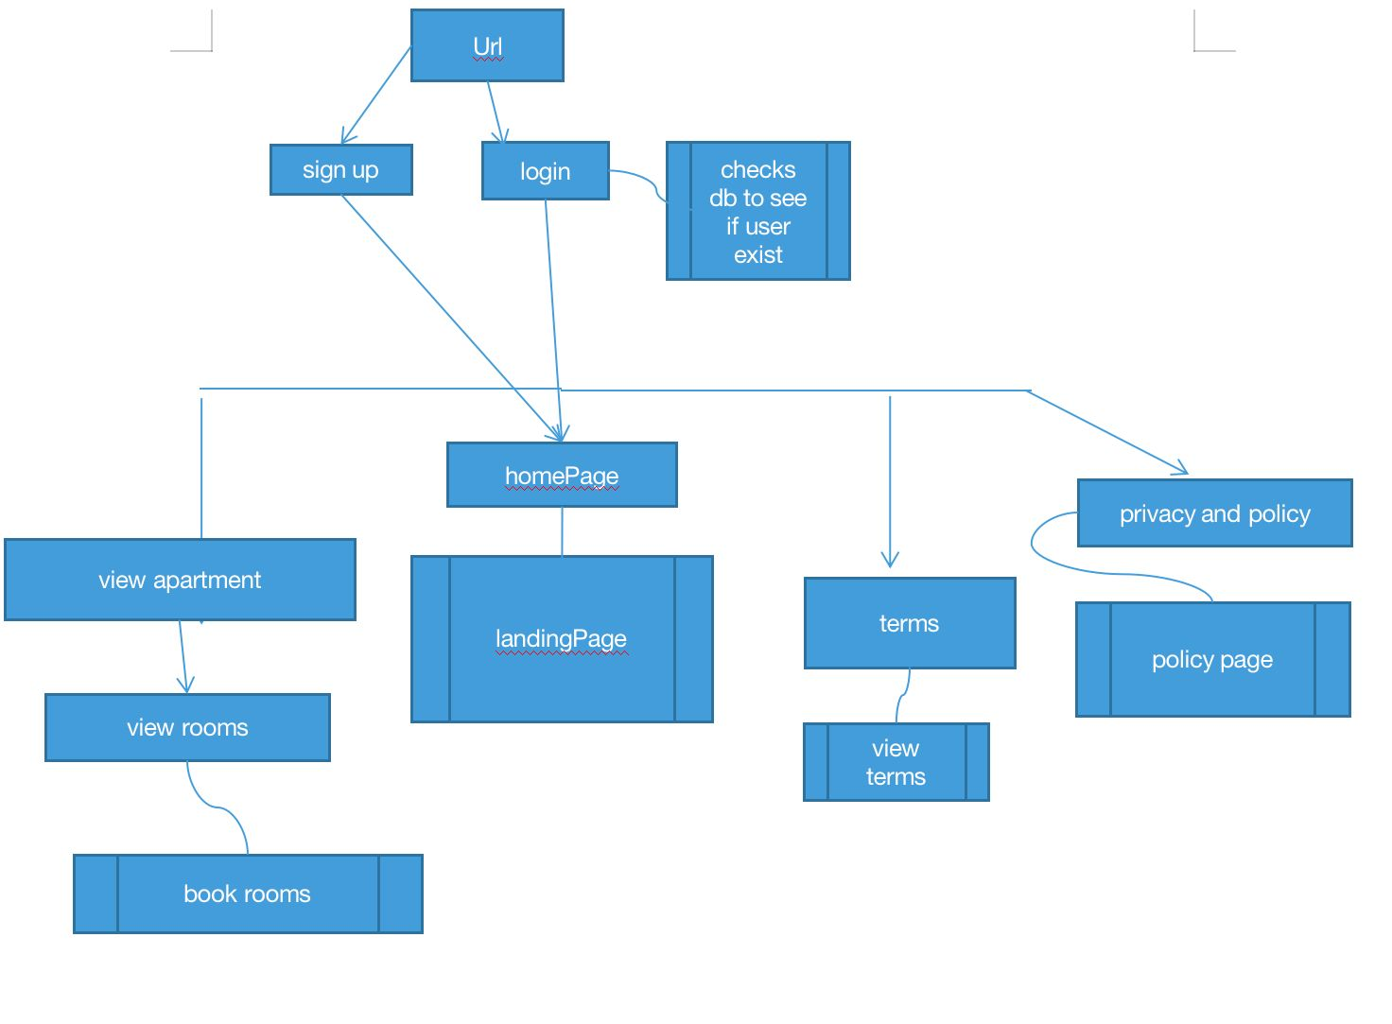

Figure 3.2 System Architecture for Student

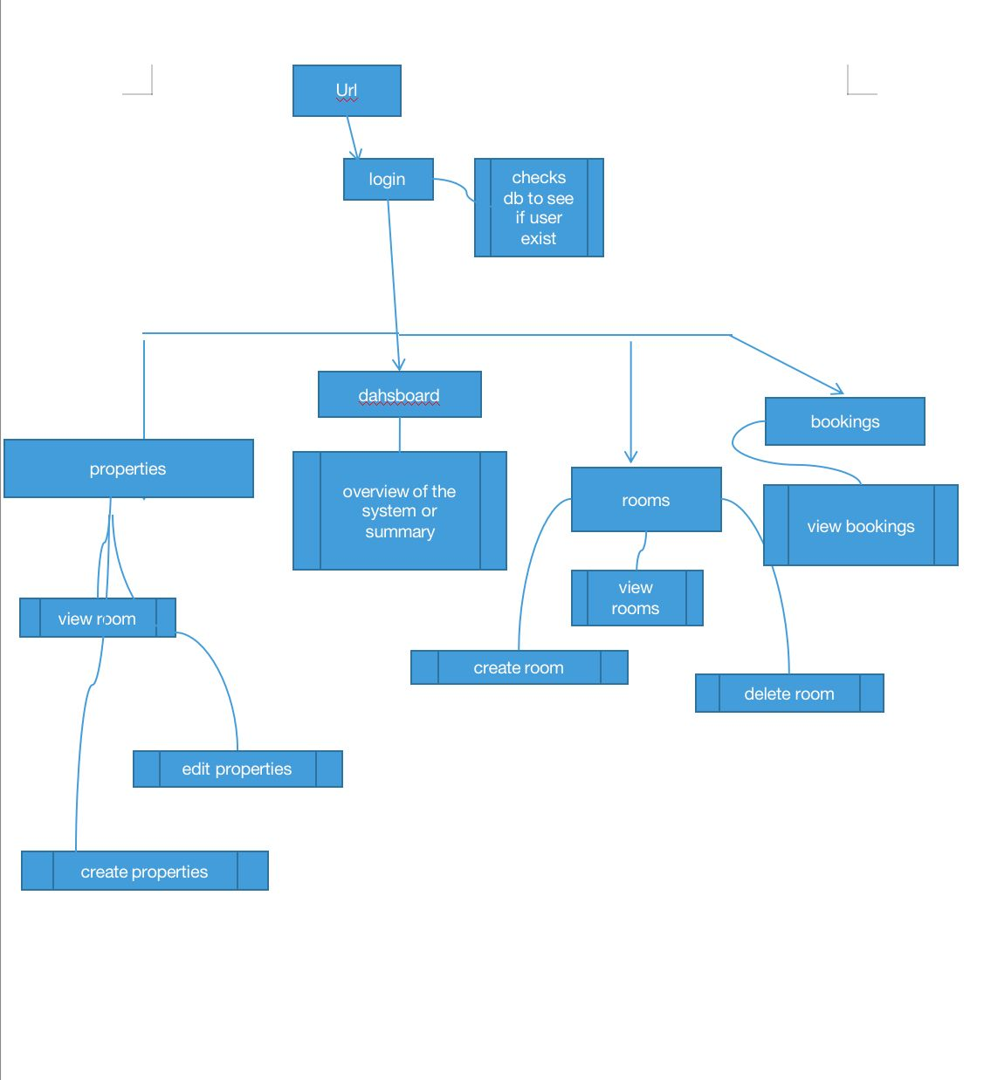

Figure 3.3 System Architecture for Admin

# 3.7.2 Use Case

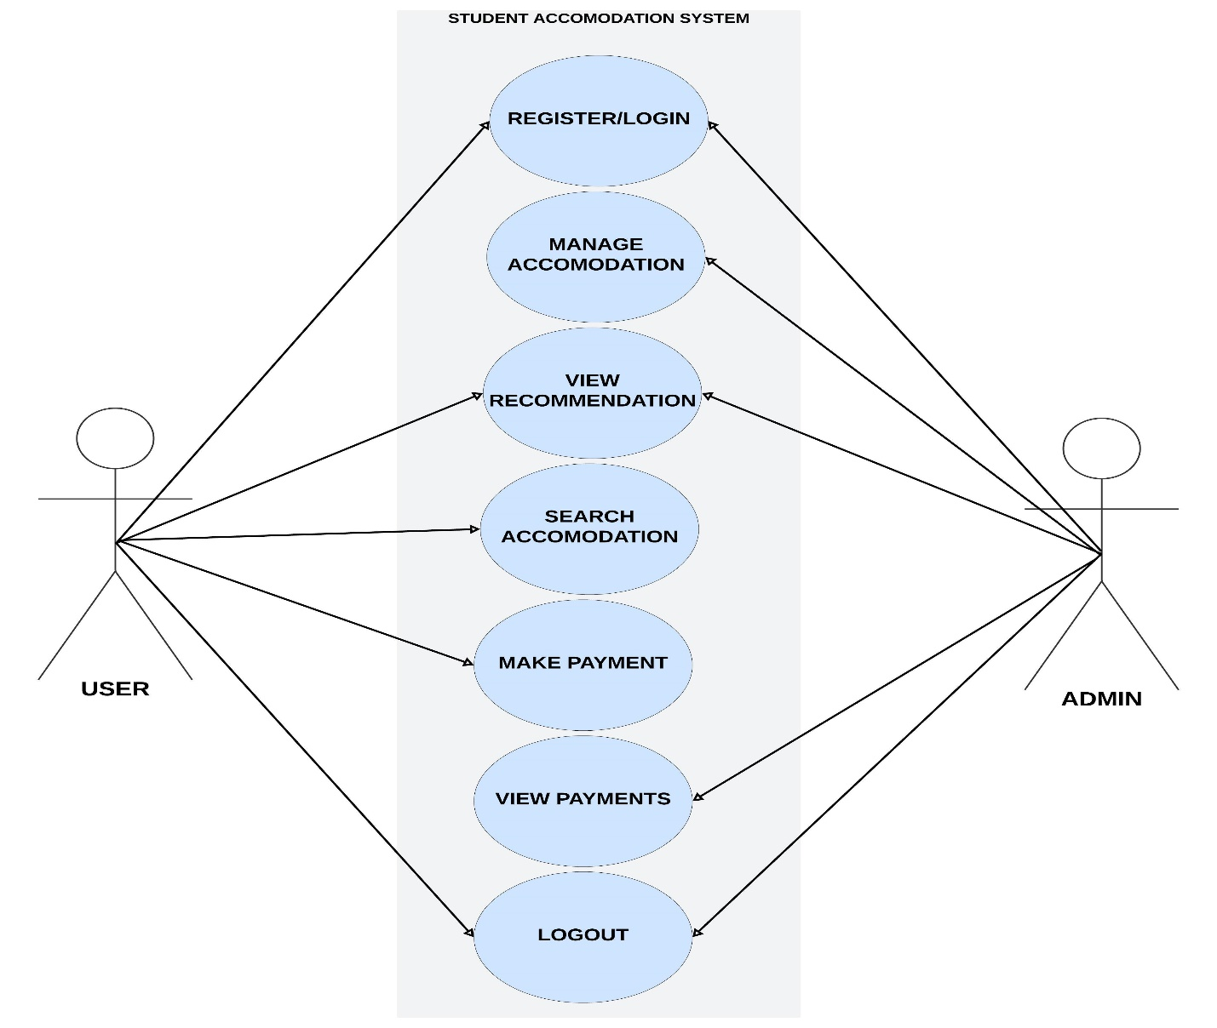

Figure 3.4: Use case Diagram

## **3.7.2.1 Use-Case Description**

**Table 3.3 Use-Case Description for Login/Register**

|  |  |  |
| --- | --- | --- |
| USE CASE | LOGIN/REGISTER | |
| Description: | This use case describes the process of logging in to an existing account or registering a new user account within the accommodation management system. | |
| Actors: | User | |
| Pre-condition: | none | |
| Post condition | Successful login grants access to the system.  Successful registration creates a new user account | |
| Main flow | User   1. User selects the login or register option. 2. When the user chooses to log in, they need to enter their login credentials 3. If the user selects register, the user provides their registration details. | System   1. System validates credentials. 2. The system validates the provided login or registration details. 3. If the validation is successful, the user will be logged into or registered in the application. 4. Use case ends |
| Exception Conditions: | * Invalid login credentials result in an error message. User can retry or cancel, ending the use case.   Invalid registration result in an error message. User can retry or cancel, ending the use case. | |

**Table 3.4 Use-Case Description for Search Accommodation**

|  |  |  |
| --- | --- | --- |
| Use Case: | Search Accommodation | |
| Description: | This use case describes the process of a user searching for available accommodations based on specific location | |
| Actor: | User | |
| Preconditions: | User is logged in  Accommodation data is available in the system | |
| Post conditions: | A list of matching accommodations is displayed to the user. | |
| Main Flow: | User   1. User Selects “Search Accommodation”. 2. User selects Available location. 3. User selects Available Rooms. | System   1. System searches the database for available Accommodation. 2. System displays list of search result. |
| Exception condition: | No accommodations found matching the searched location | |

**Table 3.5 Use-Case Description for View Payment(Admin)**

|  |  |  |
| --- | --- | --- |
| Use Case: | View Payment | |
| Description: | This use case describes the process of an administrator viewing payment history for accommodations. | |
| Actor: | Admin | |
| Preconditions: | Admin is logged in | |
| Post conditions: | Payment information is displayed. | |
| Main Flow: | Admin   1. Admin selects "View Payments". 2. Admin can filter or search for specific payments. | System   1. System searches the database for available Accommodation. 2. System displays list of search result |
| Exception condition: | No payment data available.  System error during data retrieval. | |

### **3.7.3 Activity Diagrams**

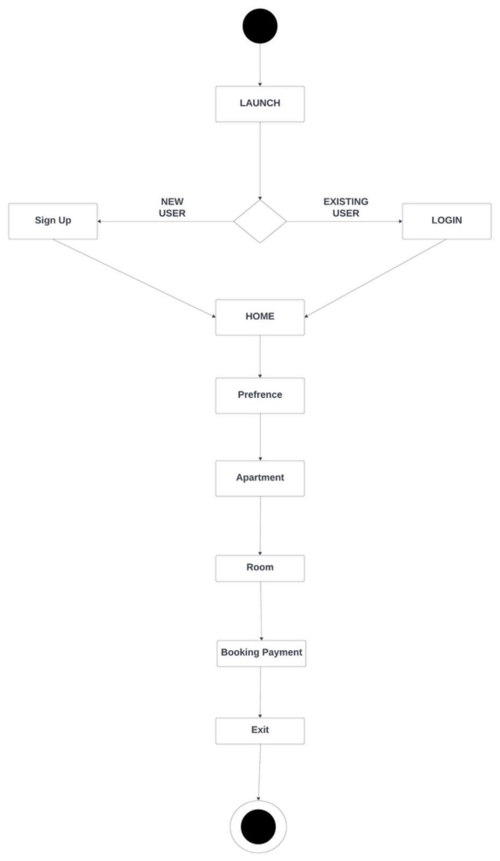

Figure 3.5 Activity Diagram (User)

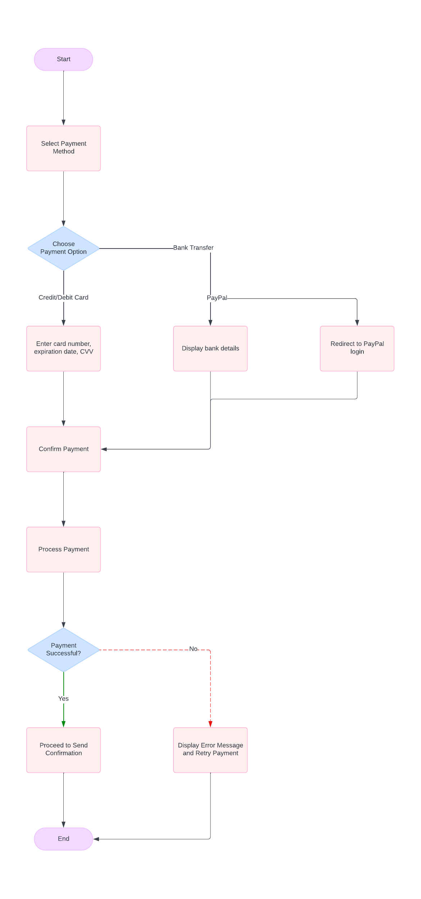

Figure 3.6 Activity Diagram (Payment)

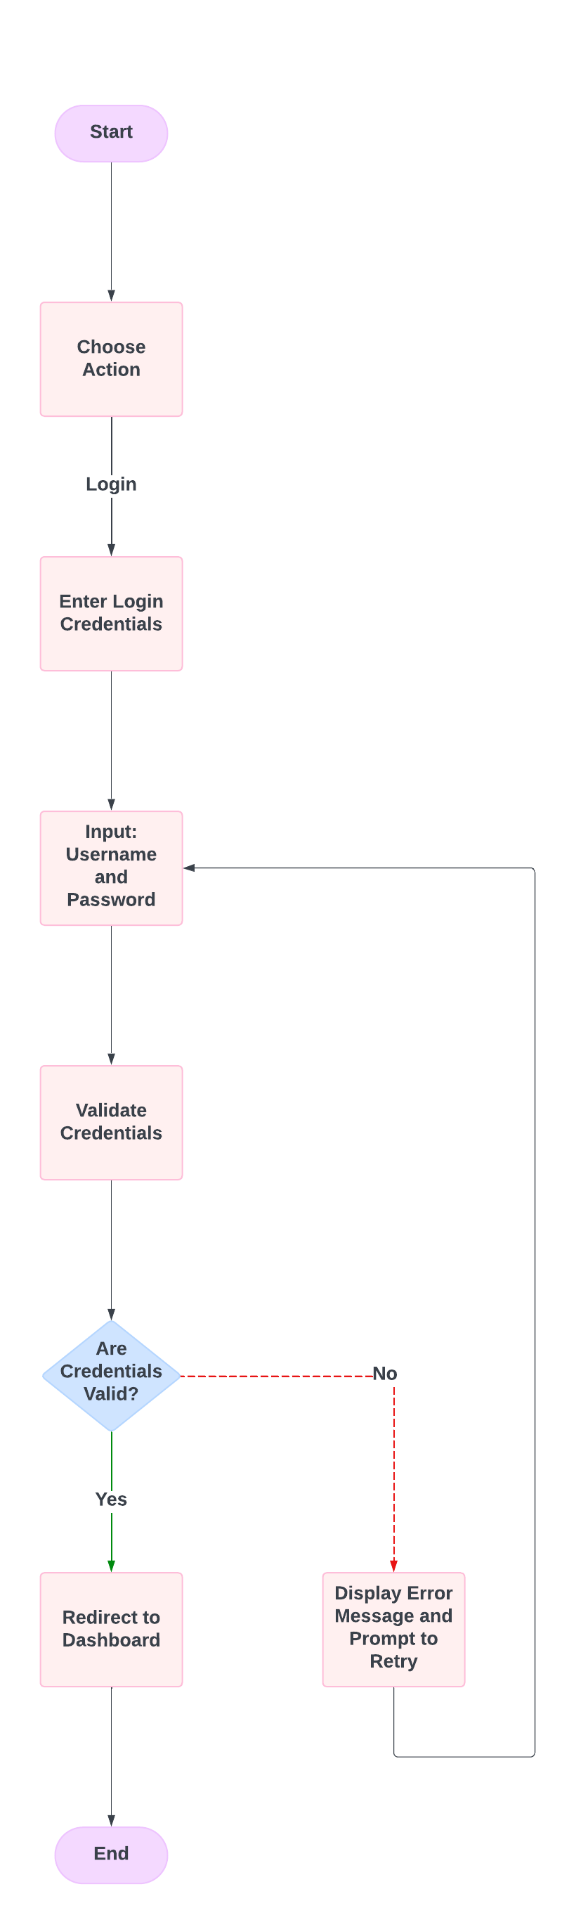

figure 3.7 Activity Diagram(Registration)

### **3.7.4 Entity Relationship Diagram**

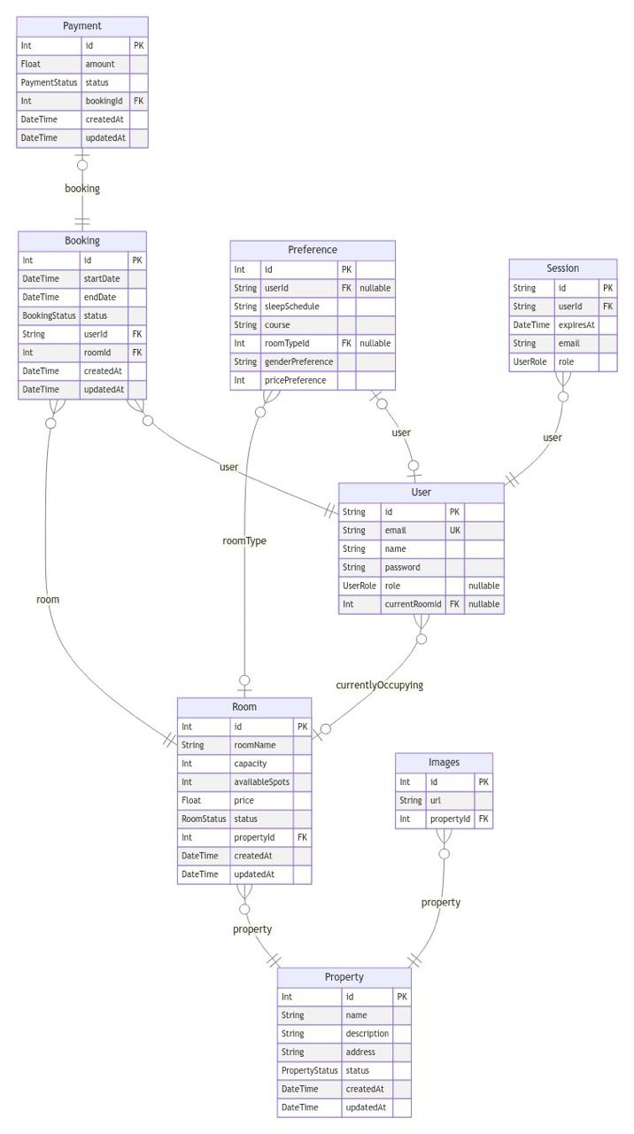

Figure 3.8 Entity Relationship Diagram

# 

# CHAPTER 4

# IMPLEMENTATION AND TESTING

## **4.1 Overview**

This chapter discusses the practical development of the system and other related factors that assisted in developing the system including the front-end, back-end, database and the challenges encountered and solutions to the challenges encountered.

## **4.2 Main Features**

1. The Student Accommodation System Using Preference is designed to make the process of finding accommodation smoother and more personalized for students while streamlining management for administrators.
2. User Registration and Login: The system includes secure login functionality, where both students and administrators can sign in using their credentials. Role-specific access ensures that users can see and interact only with the features relevant to their role.
3. Personalized Roommate Matching: Students input their living preferences, such as cleanliness, social habits, sleep schedules, and noise tolerance. The system uses these preferences to match them with available rooms and suitable roommates, helping students find accommodations that best fit their lifestyle.
4. Accommodation Availability Filtering: Based on the student’s preferences and budget, the system filters through available rooms to recommend the most compatible options. Only rooms that meet the student’s criteria are shown, simplifying the decision-making process.
5. Roommate Compatibility Algorithm: The system calculates a match score between the student and potential roommates by comparing their preferences. Rooms are then ranked based on compatibility, ensuring students are paired with roommates who are most likely to get along.
6. Payment System: Once students select their preferred accommodation, they can proceed to make payments directly through the platform. The system supports secure payment processing, allowing students to pay for their accommodation fees or deposits online.
7. User Management: Administrators have full control over managing user accounts, including adding or removing users, assigning roles, and managing permissions. They can also track student activities and respond to issues related to room assignments or payments

## **4.3 Implementation Problems**

Challenges faced during development included:

1. Incomplete information from students.
2. Verifying the authenticity of the provided data is difficult.
3. Insufficient data to make accurate recommendation.
4. Data inconsistencies and formatting issues.
5. Technical issues and errors.

## **4.4 Overcoming Implementation problem**

1. Ensuring user’s personal information id protected and secured.
2. Standardized data formats to ensure consistency.
3. Ensuring secure payment processing.

## **4.5 Testing**

Testing was conducted to confirm that the application met its requirements. The application was tested from the perspective of a user to ensure that the efficiency and reliability of the application were put to test. Other forms of testing such as unit testing ensured that the functions of the application from the front-end to the back-end were examined and tested.

**Table 4.1 Testing for User Sign up**

|  |  |
| --- | --- |
| Test Case | User sign up |
| Related Requirement | FR01 |
| prerequisites | The user can access the sign-in page |
| Test procedure | 1. Navigate to the sign up page 2. Enter the required information 3. Click on “sign up” button |
| Test Data | User Information |
| Expected Result | Account Created |
| Actual Result | Account Created |
| Status | pass |
| Remark | None |
| Created by | Maryam Abba Yusuf |
| Date of Creation | 10th August,2024 |
| Executed By | Maryam Abba Yusuf |
| Date of Execution | 10th August, 2024 |
| Test Environment | HP Laptop |

**Table 4.2 Testing for User sign in**

|  |  |
| --- | --- |
| Test Case | User sign in |
| Related Requirement | FR02 |
| prerequisites | 1. User has a valid account 2. User has access to sign in page. |
| Test procedure | 1. Navigate to the log in page 2. Enter valid username and password 3. Click on the “Sign in” button |
| Test Data | Valid Username and password |
| Expected Result | User should successfully sign in and be redirected to the home page, or a page to set preferences if not already set. |
| Status | pass |
| Remark | None |
| Created By | Maryam Abba Yusuf |
| Date of Creation | 10th August,2024 |
| Executed By | Maryam Abba Yusuf |
| Date of Execution | 10th August, 2024 |
| Test Environment | HP Laptop |

**Table 4.3 Testing for Admin**

|  |  |
| --- | --- |
| Test Case | Admin |
| Related Requirement | FR03 |
| prerequisites | 1. Admin has a valid account and is signed in. 2. Admin has access to the admin management dashboard. |
| Test procedure | 1. Login as Admin. 2. Review current room availability and occupancy status. 3. Update room availability (e.g., mark rooms as available or occupied). 4. save changes and verify that updates are reflected in the system. 5. View pending payment |
| Test Data | Room and Apartment status updates |
| Expected Result | Room availability and preferences should be updated successfully. The changes should be reflected in the system for users to see. |
| Status | pass |
| Remark | None |
| Created By | Maryam Abba Yusuf |
| Date of Creation | 10th August,2024 |
| Executed By | Maryam Abba Yusuf |
| Date of Execution | 10th August, 2024 |
| Test Environment | HP Laptop |

**Table 4.4 Testing for preference**

|  |  |
| --- | --- |
| Test Case | User Preference |
| Related Requirement | FR04 |
| prerequisites | User has a valid account  User has access to the preference page |
| Test procedure | 1. Select gender preference (Male, Female, Other). 2. Adjust sliders for cleanliness, socialness, quietness, and sleep schedule. 3. Click on the “Submit” button |
| Test Data | Selected gender preference and values for cleanliness, socialness, quietness, and sleep schedule. |
| Expected Result | Preferences should be successfully saved, and the user should be redirected to a room recommendations page |
| Status | pass |
| Remark | None |
| Created By | Maryam Abba Yusuf |
| Date of Creation | 10th August,2024 |
| Executed By | Maryam Abba Yusuf |
| Date of Execution | 10th August, 2024 |
| Test Environment | HP Laptop |

**Table 4.5 Testing for Room Selection**

|  |  |
| --- | --- |
| Test Case | User Room Selection |
| Related Requirement | FR05 |
| prerequisites | 1. User has a valid account and is signed in. 2. User has chosen an apartment and set their preferences. 3. User has navigated to the room selection page. |
| Test procedure | |  | | --- | | 1. Navigate to the room selection page. |  1. Review available rooms based on the chosen apartment and user preferences. 2. Select a room from the available options. 3. Confirm the room selection and proceed to the next step (e.g., payment). |
| Test Data | Selected apartment and user preferences |
| Expected Result | The system should display available rooms that match the selected apartment and preferences. The user should be able to select a room |
| Actual Result | The system should display available rooms that match the selected apartment and preferences. The user should be able to select a room |
| Status | pass |
| Remark | None |
| Created By | Maryam Abba Yusuf |
| Date of Creation | 10th August,2024 |
| Executed By | Maryam Abba Yusuf |
| Date of Execution | 10th August, 2024 |
| Test Environment | HP Laptop |

**Table 4.6 Testing for payment**

|  |  |
| --- | --- |
| Test Case | User Payment |
| Related Requirement | FR06 |
| prerequisites | 1. User has a valid account and is signed in. 2. User has selected a room and ready to make a payment. 3. Payment gateway is integrated with the system. |
| Test procedure | |  | | --- | | Navigate to the payment page after selecting a room. |  |  |  | | --- | --- | |  | Enter valid payment details(credit card, Bank Transfer etc.). |  |  |  | | --- | --- | |  | Confirm the amount and click the "Pay Now" button. |  |  |  | | --- | --- | |  | Receive confirmation of successful payment. | |
| Test Data | Valid payment details (e.g., credit card number, Bank Transfer) |
| Expected Result | The payment should be successfully processed, and a confirmation message or receipt should be displayed. The user should be redirected to a "Payment Successful" |
| Status | pass |
| Remark | None |
| Created By | Maryam Abba Yusuf |
| Date of Creation | 10th August,2024 |
| Executed By | Maryam Abba Yusuf |
| Date of Execution | 10th August, 2024 |
| Test Environment | HP Laptop |

## **4.5 Use Guide**

1. **User Registration and Login:**

Open the system in a web browser.

If you are a new user, click on the "Register" button and provide the required information to create an account.

If you already have an account, click on the "Login" button and enter your credentials.

1. **Administrators**

After logging in, administrators will have access to administrative functions.

View and manage student and accommodation accounts.

Perform administrative tasks, such as managing room listings, updating accommodation details, assigning students to rooms, and overseeing payment processes.

1. **Student (User)**

After logging in, students can input their preferences for accommodation and roommates (cleanliness, quietness, social habits, etc.).

View recommended rooms and potential roommates based on their preferences.

Make secure payments for their selected accommodation directly through the system.

## **4.7 User Interface Design**

**Admin’s Page**

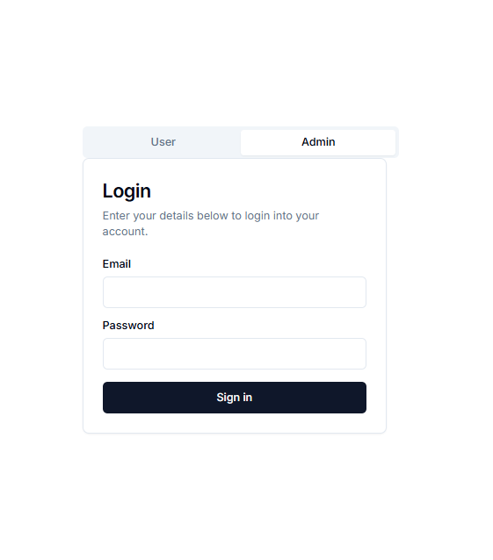

Figure 4.1: Login Page

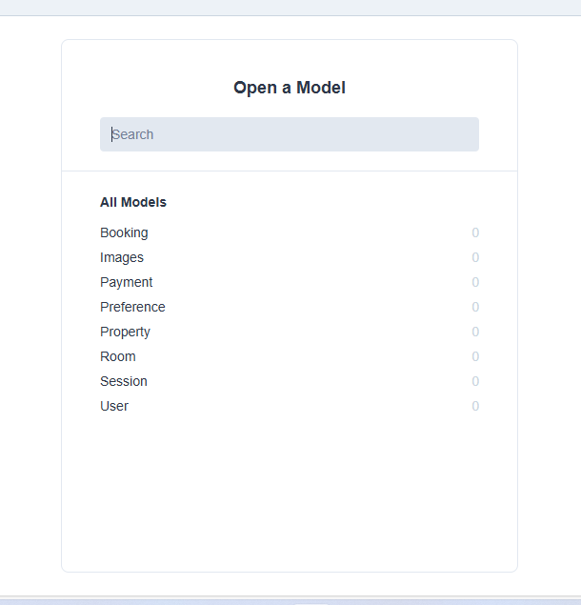

Figure 4.2: Model page

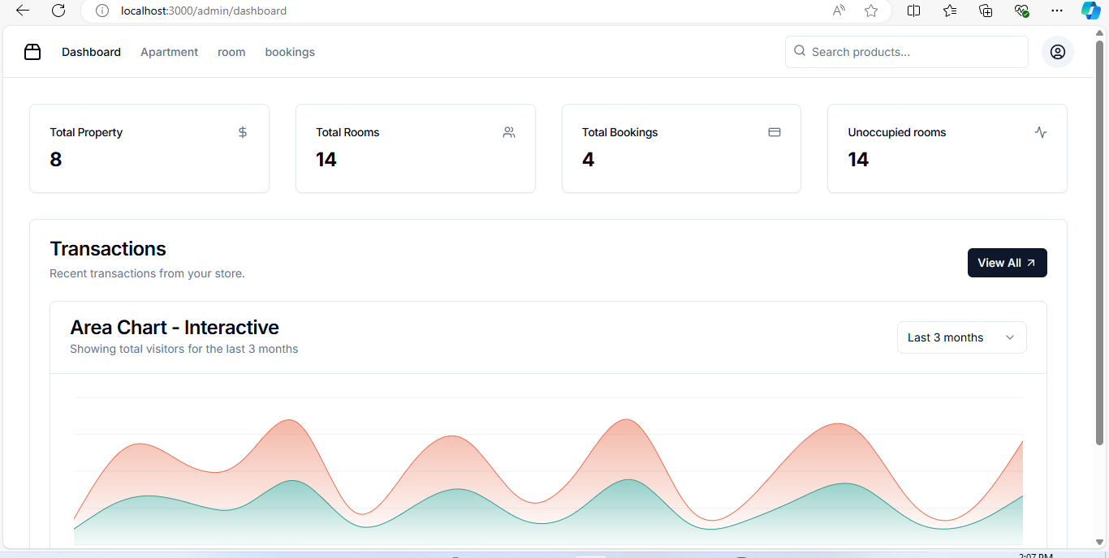

Figure 4.3: Dashboard

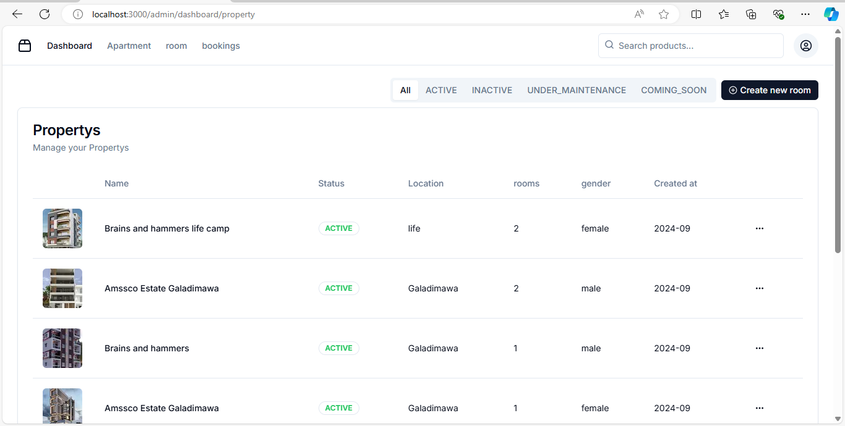

Figure 4.4: Apartment page

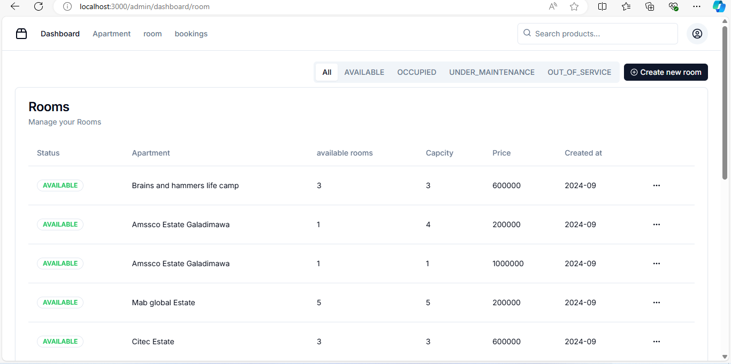

Figure 4.5: Room page

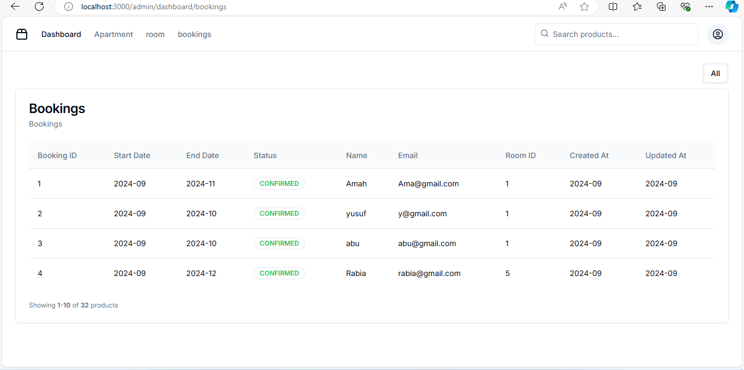

Figure 4.6: Booking/payment page

**User’s View**

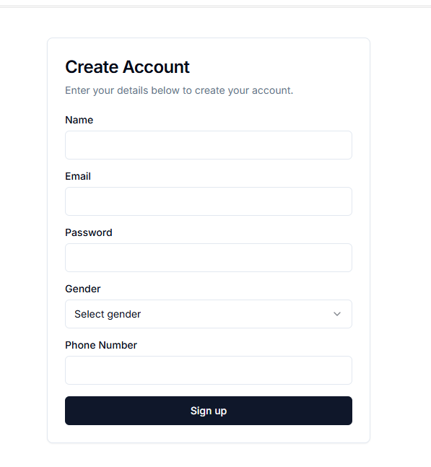

Figure 4.7: Sign up page(user)

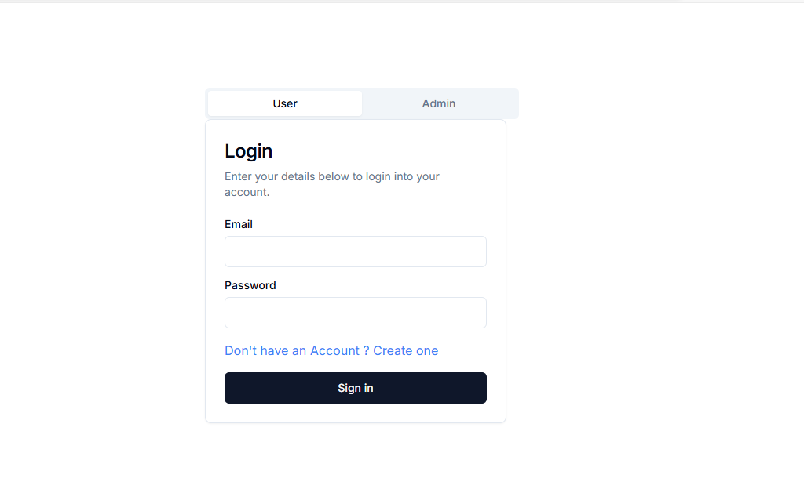

Figure 4.8: Login page(user)

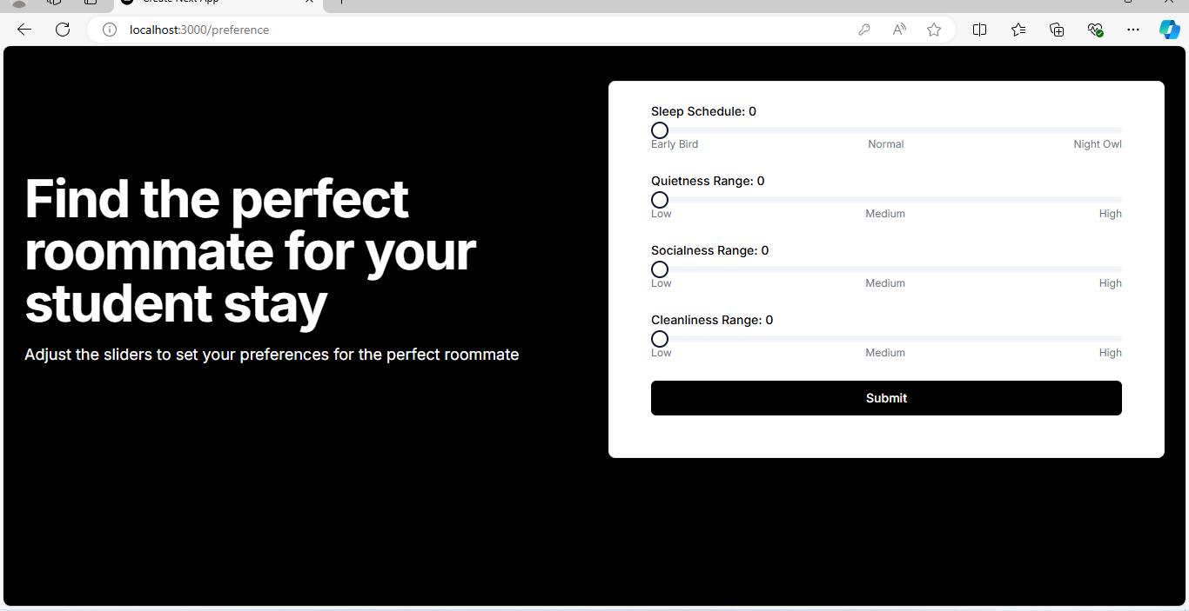

Figure 4.9: Preference page

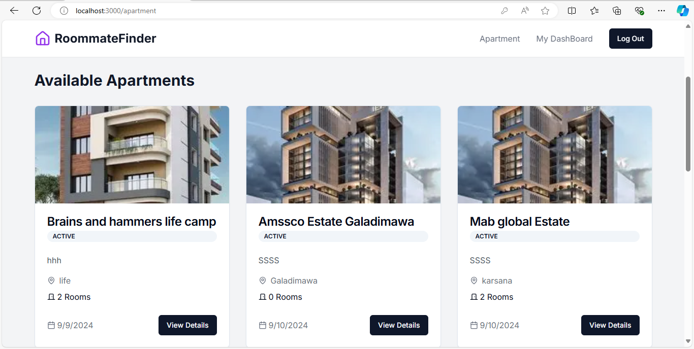

Figure 4.10: Apartment page

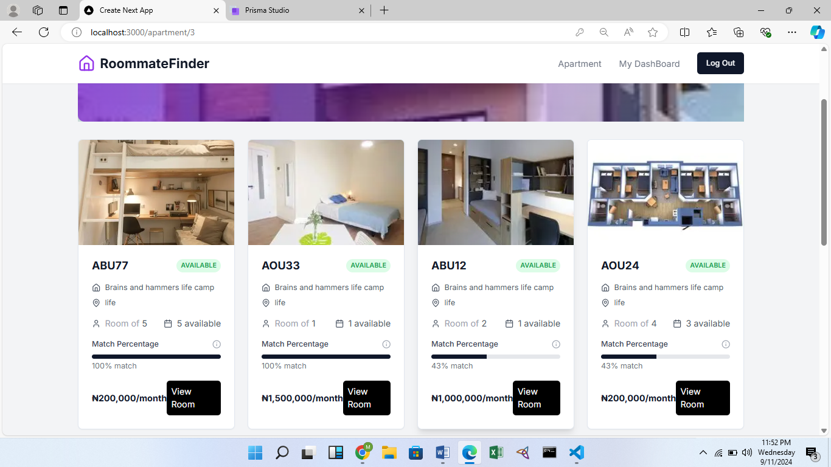

Figure 4.11: Room page

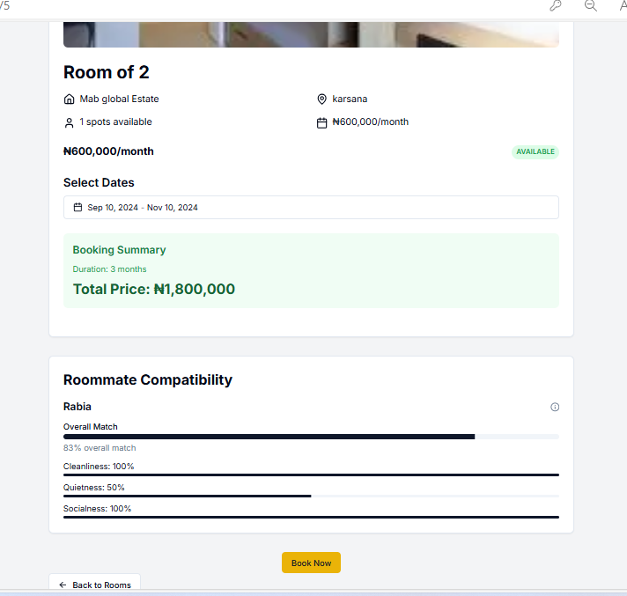

Figure 4.12: Booking Page

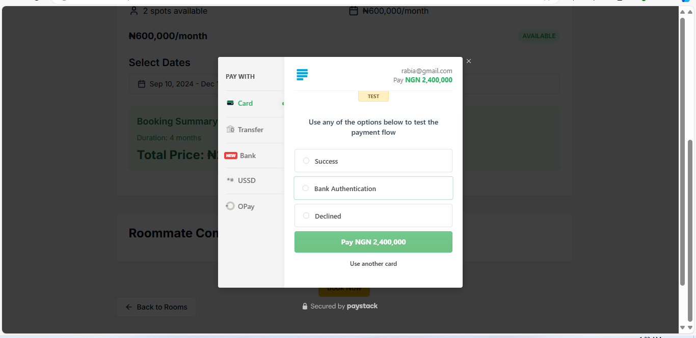

Figure 4.13: Payment page

# CHAPTER 5

# DISCUSSION, CONCLUSION AND RECOMMENDATION

## **5.1 Overview**

This concluding chapter provides a comprehensive reflection on the implementation of the student accommodation using preference Matching. It evaluates the achievements relative to the initial objectives of the project. Additionally, it highlights the main challenges encountered and the system's limitations. The chapter concludes with recommendations for future enhancements, along with final observations.

## **Objective Assessment**

* 1. Automating the process of assigning accommodations to students.
  2. Providing personalized housing suggestions based on each student's needs and preferences.
  3. Bringing together all accommodation options in one place for easier browsing.
  4. Enhancing the accuracy of housing recommendations through data analysis is important.

The system built during this project effectively matches students' preferences with available housing options. This has significantly reduced the manual work required to manage student accommodation requests, making the process easier for both students and staff.

## **5.3 Limitations and Challenges**

1. The mobile interface for the system is underdeveloped, leading to usability issues on smaller devices.
2. The recommendation engine requires more extensive data sources to improve its accuracy.
3. Customizable reports for staff and administrators are limited and require additional technical support.
4. Student self-service functionalities such as payment integration and room change requests remain limited.
5. The project has accumulated technical debt due to rapid development phases, and this will require dedicated resources for optimization, security, and future-proofing. Additionally, there are concerns regarding long-term maintenance and support, which will require a well-trained team to handle future updates.

## **5.4 Future Enhancements**

1. Build mobile apps for iOS and Android to make the system easier to use.
2. Improve the recommendation engine by using more data sources, including outside housing databases.
3. Make reporting easier for staff by creating a simple tool that does not require technical help.

## **5.5 Recommendations**

1. Set a reminder for renewal of payments
2. Set up a plan for feedback from users to keep improving the system.

## **5.6 Summary**

The Student Accommodation System (Preference matching) is a big step toward making the process more efficient and tailored for students. However, to fully benefit from the system, ongoing support from leadership and stakeholders is needed. With regular updates, proper resources, and smart improvements, the system can boost student satisfaction and improve how things are run. By using modern technology, the institution can become a leader in student housing, setting the stage for future success.

# REFERENCES

Aggarwal, C. C. (2016). Recommender systems. Springer International Publishing.

Breese, J. S., Heckerman, D., & Kadie, C. (1998). Empirical analysis of predictive algorithms for

collaborative filtering (Technical Report MSR-TR-98-12). Microsoft Research.

Basavesh, D., Laharishree, S., Sthuthi, S., Tejaswini, N., & Vidya, R. (2023). Hostel finder:

Location-based recommendation system for hostels and PGS with transit information. International Journal of Research Publication and Reviews. <https://www.ijrpr.com>

Burke, R. (2001). Knowledge-based recommender systems. In Encyclopedia of library and

information science.

Burke, R. (2002). Hybrid recommender systems: Survey and experiments. User Modeling and

User-Adapted Interaction, 12(4), 331-370.

Carpenter, S. R., Pingali, P. L., Bennett, E. M., & Zurek, M. B. (Eds.). (2005). Ecosystems and

human well-being: Scenarios, volume 2. Island Press.

Daly, E. M., Botea, A., Kishimoto, A., & Marinescu, R. (2014). Multi-criteria journey aware

housing recommender system. In Proceedings of the 8th ACM Conference on Recommender Systems (pp. 325-328). ACM.

Desai, U. (2023, April 27). Recommendation systems explained: Understanding the basic to

advance. Medium. <https://utsavdesai26.medium.com/Apr> 27, 2023

Ikejiaku, B. V. (2009). The relationship between poverty, conflict and development. Journal of

Sustainable Development, 2(1), 15. <https://doi.org/10.5539/jsd.v2n1p15>

Isinkaye, F., Folajimi, Y., & Ojokoh, B. (2015). Recommendation systems: Principles, methods

and evaluation. Egyptian Informatics Journal, 16, 100-105. <https://doi.org/10.1016/j.eij.2015.06.005>

Jain, A., & Gupta, C. (2018). Fuzzy logic in recommender systems. In Fuzzy logic augmentation

of neural and optimization algorithms: Theoretical aspects and real applications (pp. 255-273). Springer.

Lorenzi, F., Fontanella, B., Prestes, E., & Peres, A. (2014). How to improve multi-agent

recommendations using data from social networks? In FLAIRS Conference.

Omisore, M. O., & Samuel, O. W. (2014). Personalized recommender system for digital libraries.

International Journal of Web-Based Learning and Teaching Technologies, 9(1), 18-32. <https://doi.org/10.4018/IJWLTT.2014010102>

Omisore, M. O., Samuel, O. W., & Ogunniyi, T. O. (2013). A multi-technique approach for

recommender systems. International Journal of Advanced Trends in Computer Science and Engineering, 2(5), 112-118. <https://doi.org/10.30534/ijatcse/2013/02252013>

Ojokoh, B., Omisore, M., Samuel, O., & Ogunniyi, T. (2012). A fuzzy logic based personalized

recommender system. International Journal of Computer Science and Information Technology and Security, 2(5), 1008-1015.

Osgood, C. E., Suci, G. J., & Tannenbaum, P. H. (1957). The measurement of meaning. University

of Illinois Press.

Pizzato, L., Rej, T., Chung, T., Koprinska, I., & Kay, J. (2010). RECON: A reciprocal

recommender for online dating. In Proceedings of the Fourth ACM Conference on Recommender Systems (pp. 207-214). ACM.

Sarwar, B., Karypis, G., Konstan, J., & Riedl, J. (2001). Item-based collaborative filtering

recommendation algorithms. In Proceedings of the 10th International World Wide Web Conference (pp. 285-295). ACM.

Schafer, J. B., Konstan, J. A., & Riedl, J. (1999). Recommender systems in e-commerce. In

Proceedings of the 1st ACM Conference on Electronic Commerce (pp. 158-166). ACM.

Schafer, J. B., Konstan, J. A., & Riedl, J. (2002). Meta-recommendation systems: User-controlled

integration of diverse recommendations. In Proceedings of the Eleventh International Conference on Information and Knowledge Management (pp. 43-51). ACM.

Shanmuganathan, M., & Karthikeyan, R. (2016). A web-based recommendation system for

housing selection: Design, implementation & evaluation. Data Mining and Knowledge Engineering, 8(5), 134-137. <https://doi.org/10.11648/j.dmke.2016.08.05.14>

Terveen, L., Hill, W., Amento, B., McDonald, D., & Creter, J. (1997). PHOAKS: A system for

sharing recommendations. Communications of the ACM, 40(3), 59-62. <https://doi.org/10.1145/253610.253623>

Yuan, X., Lee, J. H., Kim, S. J., & Kim, Y. H. (2013). Toward a user-oriented recommendation

system for real estate websites. Information Systems, 38(2), 231-243. <https://doi.org/10.1016/j.is.2012.10.003>

Zain, J., & Khurshed, T. (2020). Hostel recommender system [Unpublished final year project].

Department of Computer Science and IT, Bahria University Lahore Campus.

# APPENDICES

**Appendix A – Project Document**

**IN-DEPTH PROJECT DOCUMENTATION**

**Full Candidate Name**: Maryam Abba Yusuf

**Student ID**: BU/22B/IT/6965

**Title**: Student Accommodation System (Preference Matching)

**Course of Study**: B.Sc. Software Engineering

**Background and Motivation**

Student accommodation is a critical aspect of university life, ensuring that students have safe, affordable, and convenient places to live while pursuing their studies. In Abuja, the capital city of Nigeria, the demand for student housing has surged with the growing number of higher education institutions and students. Options range from university to private student housing complexes, shared apartments. However, finding the right accommodation that meets the diverse needs and preferences of students remains a challenge in Abuja's dynamic real estate market.

Initially, the process of finding student accommodation was manual, relying on physical visits, word of mouth, and simple listings. This approach was time-consuming, and often resulted in mismatches between students’ needs and available housing options (Johnson, 2019). As student populations grew and the variety of housing options expanded, these manual processes became increasingly inadequate.

The system developed for this project leverages modern algorithms to match students based on their stated preferences. This approach is both personalized and data-driven, ensuring that users are matched with roommates and rooms that align with their living style.

The main goal of this system is to improve the student living experience by minimizing potential conflicts between roommates and promoting positive interactions. Students can specify their detailed preferences, which the system uses to suggest compatible rooms and roommates. This process is efficient, benefiting both students and accommodation managers by saving time and effort.

Additionally, the system gives students a sense of empowerment, knowing their living preferences are considered, which can result in higher satisfaction and increased retention for housing providers.

**Statement of the Problem**

Students often struggle to find suitable accommodation due to limited knowledge of available options and difficulty matching their preferences with available housing and roommates. This project addresses these challenges by proposing a **Student Accommodation System Using Preference Matching**, which helps students find accommodation that aligns with their specific needs, simplifying the search process and improving satisfaction

**Appendix B – Interview**

I conducted an informal interview with some of the students.

Questions asked are:

How do you currently search for student accommodation?

How would you describe your experience in finding accommodation as a student?

What factors do you prioritize when looking for student accommodation?

Would you find it useful if a system recommended accommodation based on your preferences?

What features would you like to see in a recommendation system for student accommodation?

What are the common deal-breakers for you when selecting accommodation?

what could be improved in the current methods of searching for student accommodation?

**Appendix C – Source Codes**

